Introduction to C/C++

Comp 295

Spring 2023



Department of Computer Science

Forman Christian College University

Lab 2

Conditional Statements

&

Loops

|  |  |
| --- | --- |
| **Question #** | **Total Marks** |
| Question 1 | - |
| Question 2 | - |
| Question 3 | - |

# **Example Code**

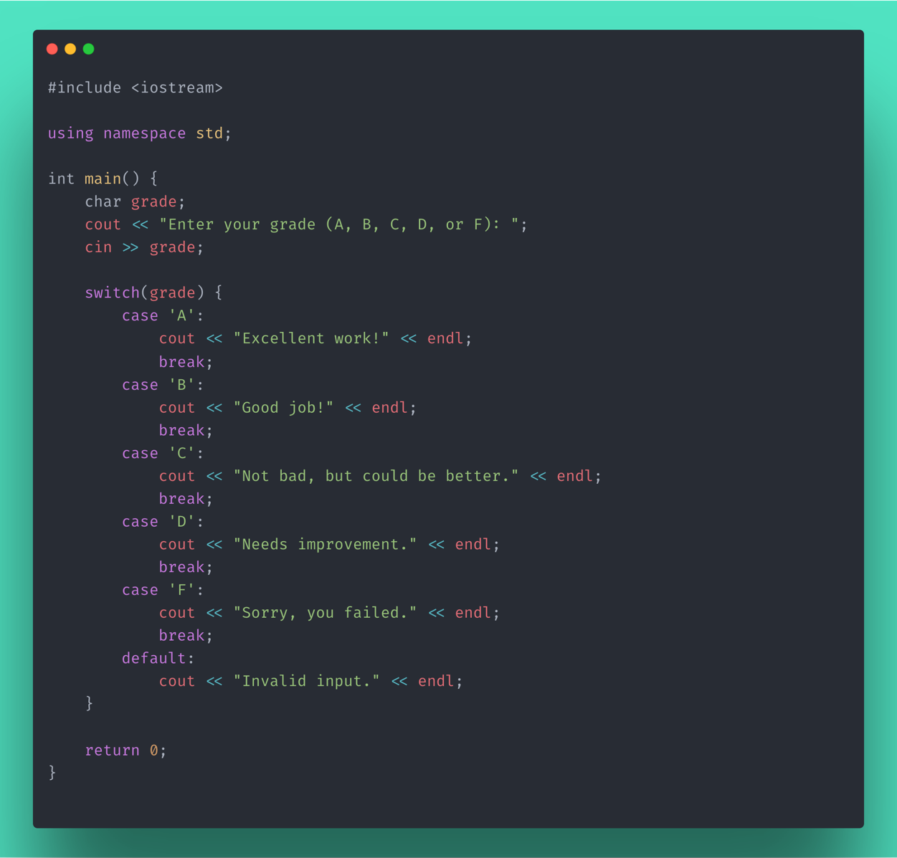

In the above example, the program prompts the user to enter a letter grade (A, B, C, D, or F) and uses a switch statement to output a corresponding message based on the input grade. If the input grade does not match any of the cases, the default block is executed.

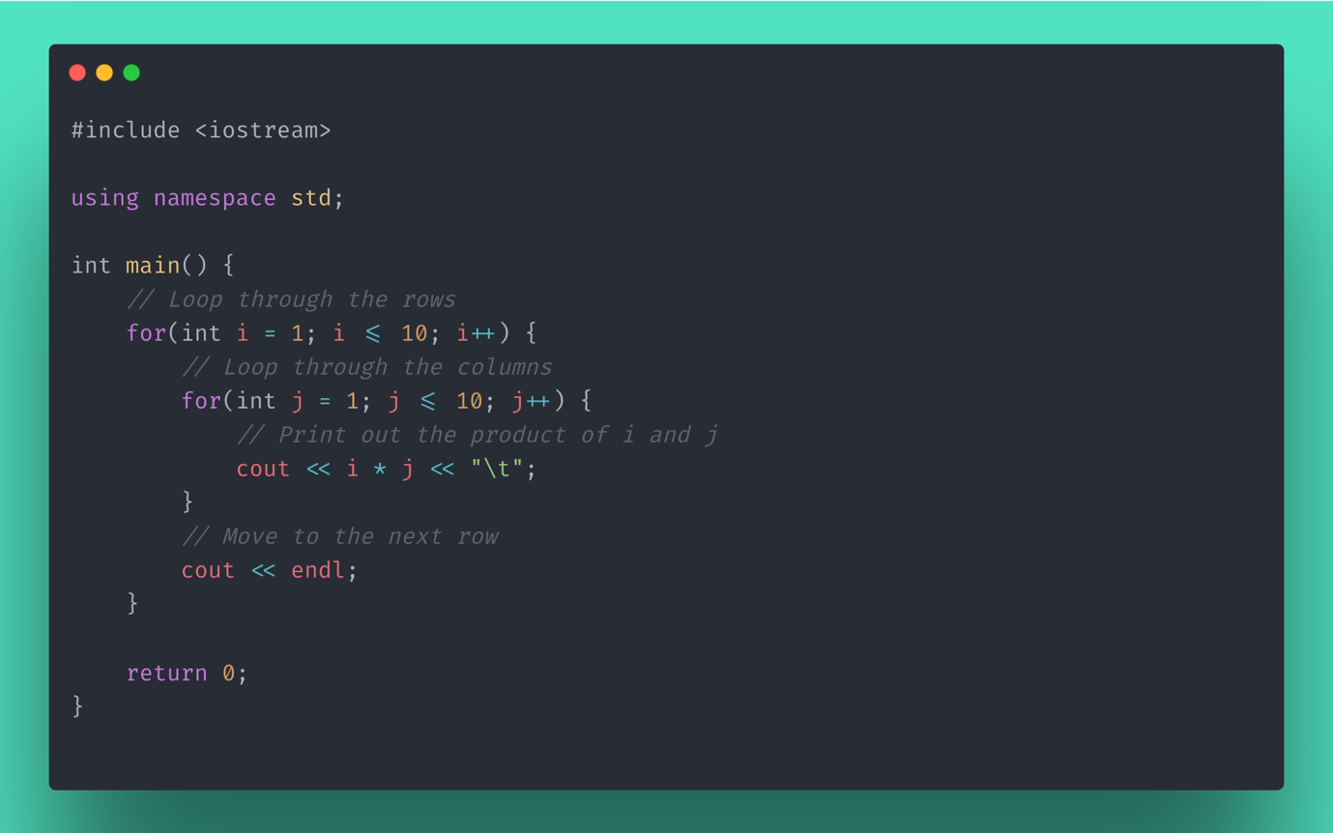

In the above example, the program uses nested for loops to print out a multiplication table.

**In Lab Problem**

**Question 1.** Write a program that inputs a character from the user and checks whether it is a vowel or consonant using switch statement. For example, if user input ‘a’ or ‘A’, the output should be something like-” Entered letter is a vowel”. Before checking a character to be vowel or consonant, program first, must verify whether the entered character is a valid English letter or not. You must use **switch statement** for this preliminary verification.

**Question 2.** Write a C++ program to find and display all the Pythagorean triplets, which are sets of three integer values for the sides of a right triangle, where the sum of the squares of two of the sides is equal to the square of the hypotenuse. The program should output the triplets in the format <side1, side2, hypotenuse> that have a sum of squares of the three sides less than 100. **To accomplish this, you can use a triple-nested for loop that tries all possibilities. E.g., <4,3,5>**

**Question 3.** Write a program in C++ to find the frequency of each digit taken from the user

Sample Output:

Input any number: 122345

The frequency of 0 = 0

The frequency of 1 = 1

The frequency of 2 = 2

The frequency of 3 = 1

The frequency of 4 = 1

The frequency of 5 = 1

The frequency of 6 = 0

The frequency of 7 = 0

The frequency of 8 = 0

The frequency of 9 = 0

**You can use a loop and switch statement to do this task.**

**Question 4.** Write a program to recreate the following pattern using the nested iterative structures. Please note that the pattern changes according to the input. Restrict the user to valid positive integer input and terminate in case of the invalid input. You can use any looping type. (For, While, Do-While)

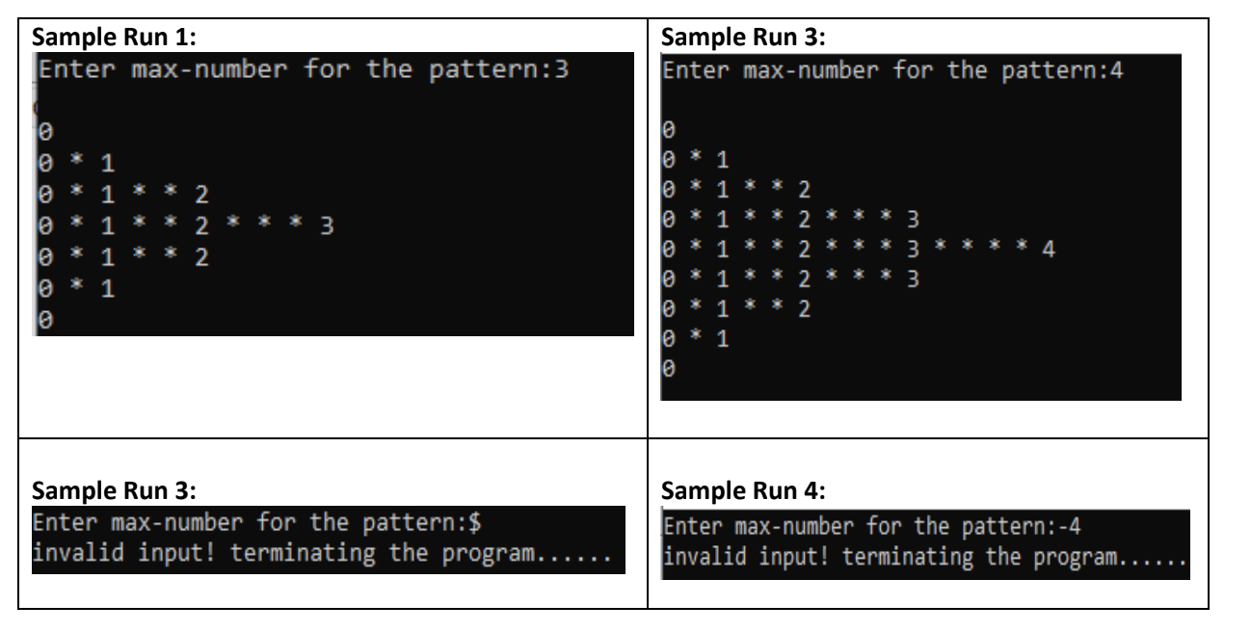

**Think of it in terms of rows and columns.**